08.05 -
Release to service
Process Design & AMOS Configuration Document
Purpose
This Process Design document is provided to Key-Users to record their key decisions regarding the AMOS Process design and the required AMOS configuration.
It is updated throughout the Project Definition Phase and used as the baseline for the Final Acceptance prior to Go-Live
Revision
Author, Name | Date | Notes
GAVG | 12.06.2024 | First Revision
DEOS | 16.12.2024 | Revision for 24.12
DEOS | 23.07.2025 | Flow update for 25.6

Table of Contents
1. Process Overview & Objectives 3
2. Regulatory References 3
3. Definitions & Glossary 3
4. Process Tasks 4
5. Process Dependencies 4
6. Process Flow 5
7. Process Design Questions 6
8. Data (Source) Mapping 7
9. Other Software Used 7
10. AMOS Configuration 7
a. Basic Data 7
b. Parameters 7
c. Workflows 7
d. Scheduled Tasks 8
e. API’s & Interfaces 8
11. Annex – Additional Info 8
a. Maintenance Release to Service 8

Process Overview & Objectives

Process General Description:
The Release to Service process covers the release of maintenance work performed on aircraft or components, which allows the aircraft or component to be released back to service. The release to service shall be performed by a therefore approved organisation and by authorized and qualified personnel.
Main Process Objective (Outputs & Outcomes) :
- Performed maintenance work has been executed as per the ordered scope.
- Qualified personnel generated and signed the Certificate of Release to Service (CRS).
- CRS can be communicated with relevant stakeholders.

Regulatory References

The following regulatory references are linked to this business process:
- EASA Part-145 145.A.45 – Maintenance data
- EASA Part-145 145.A.48 – Performance of maintenance
- EASA Part-145 145.A.50 – Certification of maintenance
- EASA Part-M M.A.801 – Aircraft certificate of release to service
- EASA Part-145 145.A.55 – Record Keeping
- EASA Part-145 145.A.65 – Maintenance procedures

Definitions & Glossary

Key-Words | Explanation
Workpackage | The workpackage is the container for various maintenance events. Unscheduled and scheduled maintenance event can be included. Workpackages are handed over to the MRO to clearly define the scope of work.
Workorder (W/O) | The workorder is the object were all maintenance activities are recorded. In connection with unscheduled maintenance all defect / malfunction are recorded in a workorder. The workorder can be created in different ways.
CRS | Certificate of Release to Service. This certificate is the declaration of authorized personnel stating that the ordered maintenance work has been carried out in accordance with approved procedures.
RTS | Release to Service

Process Tasks

Main Process Task / Actions / Activities:
The following actions are performed in this Business Process:
- Review the work performed: The staff which is going to perform the Release to Service should review the maintenance work performed to ensure everything is completed in accordance with approved procedures and requested scope. If the CRS is given for an individual maintenance task (Workorder) this is done on Workorder level. If the CRS is given for a Workpackage, then the full Workpackage should be reviewed. If the work appears incomplete or unsatisfactory, the staff will not perform the CRS.
- Review unperformed work: In case unperformed or unsatisfactory work is found, a decision will need to be made to perform the work or agree to defer the work.
- Generate the CRS: Once the performed maintenance work is found OK, the workpackage can be released with the CRS.
- Communicate the CRS: If required, the released work shall be communicated to relevant stakeholders.

Process Dependencies

The following dependencies were identified for this business process:
- AMOS process 08.02 Performing Maintenance
- AMOS process 08.03 Deferral Handling
- AMOS process 00.07 eSignature & Certificates

Process Flow

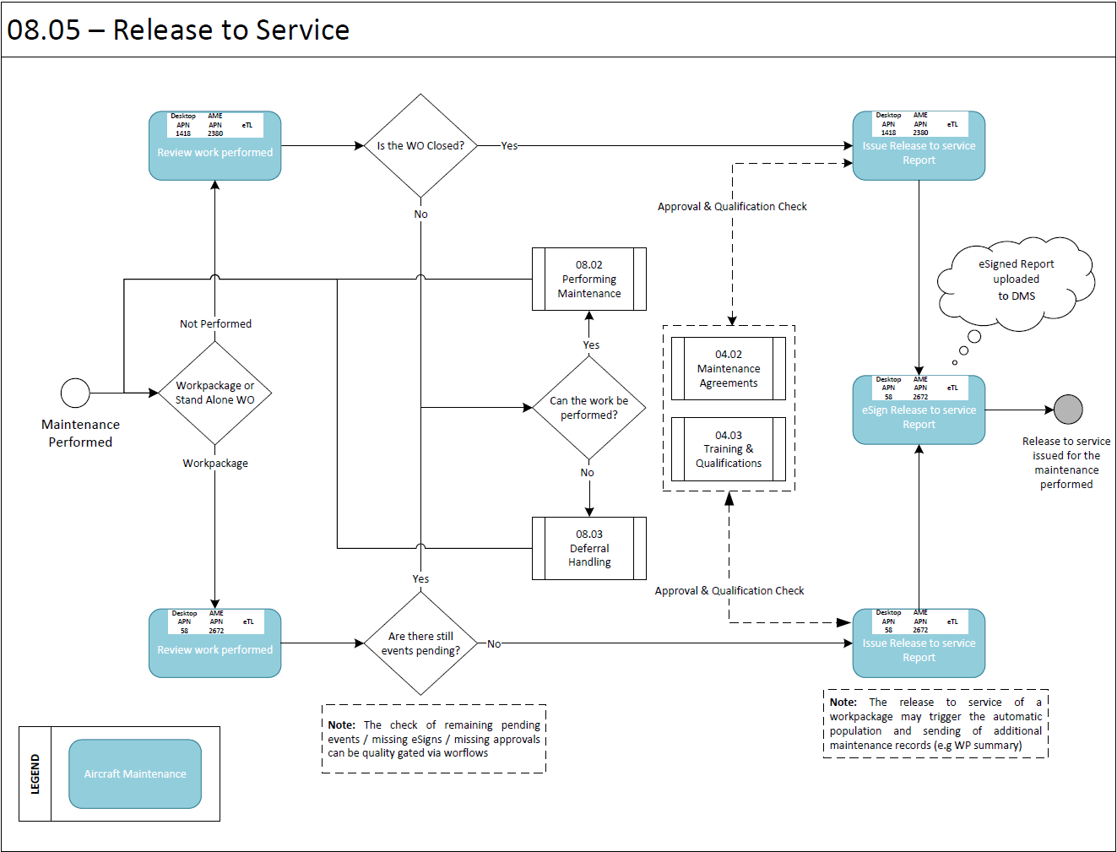

Process Design Questions

# | Question | Answer
1 | What is the current process for Aircraft or Component Release to Service?
2 | Will all work always be released on the Workpackage level or will you use standalone Workorder releases?
3 | How is the release to service communicated to relevant stakeholders?
4 | Will Electronic Signatures be used for the CRS process?
5 | If applicable, what will the release process look like for third party aircraft or components?
6 | Are there any AIM configurations or other interfaces required upon release of maintenance work?
7 | Which Quality Gates should be introduced before the WP is released to service?
8 | What documentation should be archived at the WP release?  What documentation shoud be eSigned?

Data (Source) Mapping

Data Sources | Description | Volume / Manual / Automatic / Static / Dynamic
-Nil-

Other Software Used

Other Softwares | Used by: | Description
-Nil-

AMOS Configuration

Basic Data

Basic Data Table | Notes
-Nil-

Parameters
Please refer to AMOS APN: 1442 – Parameter Setup for full details on these parameters.
Parameter Code | Parameter Name | Notes
1741 | Workpackage not performed, defer, release configuration | This parameter controls the automatic de-assignment of deferred and not performed events.
1806 | Auto de-assign on deferral / not perform based on priority | You can specify all priorities for events (defined in basic data) separated by a semicolon that should not be automatically de-assigned.

Workflows

Workflow Number | Workflow Name | Notes
98 | After saving, deleting and creating a workpackage | This workflow is started after a Workpackage is created, modified or deleted.
406 | After W/O Saved in AME | This workflow is started after a W/O is saved in AME
411 | After WP Event is closed deferred or marked as not performed | This workflow is started after a W/P event is closed, deferred, or marked as not performed.
439 | W/P event is closed, deferred, or marked as not performed. | This workflow is started before a W/P event is closed, deferred, or marked as not performed.
464 | After E-Signature on CRS Report has been made | This workflow is triggered after a CRS report has been signed via e-signature.
512 | W/P event is closed, deferred, or marked as not performed | This workflow is started after a W/P event is closed, deferred, or marked as not performed.
528 | Aircraft WP event reopened or undo action | This workflow is started after a W/P event has been reopened or moved to pending from deferred or not performed using Undo action
529 | Component event WP reopened | This workflow is started after a component W/P event has been reopened or moved to pending from deferred or not performed using Undo action

Scheduled Tasks

Scheduled Task Reference | Frequency | Notes
-Nil-

API’s & Interfaces

Reference | Direction | Trigger | Frequency
TRANSFER MRO WORKPACKAGE | Export | Workflow | Workflow
TRANSFER MRO RESULT | Export | Workflow | Workflow

Annex – Additional Info

Maintenance Release to Service
The following aspects are to be considered for the release to service:
- The owner/operator (or contracted CAMO, if existing) is responsible for all activities aimed to determine the airworthiness status of the aircraft and to appropriately plan and coordinate maintenance, and
- The contracted maintenance organisation or, when permitted by the rule, the independent certifying staff, are responsible for adequately performing and certifying the maintenance ordered by the owner/operator/CAMO.
- The operator (CAMO) cannot issue Certificates of Release to Service (CRS) following maintenance. The CRS must be issued always by certifying staff of the Part-145 organisation.
- When maintenance is performed and released by the Part-145 organisation, the operator must have procedures to verify that all the maintenance ordered to that organisation has been released to service by the approved Part-145 organisation. However, in order to perform this verification, the operator (CAMO) is not required to use certifying staff.
- Since the CRS only certifies that the maintenance ordered by the operator (CAMO) has been performed and released in accordance with Part-145, it does not guarantee that all the continuing airworthiness requirements are met (there may be some missing maintenance that has not been ordered by the operator). This is the responsibility of the operator (CAMO).
- Consequently, the operator (CAMO) must have procedures to ensure that a flight does not take place unless all the continuing airworthiness requirements are met. This could be met, for example, by a procedure where the operator (CAMO) receives a communication from the maintenance organisation and the operator (CAMO) notifies to the commander that there is no other maintenance due. However, other procedures are possible, for example, delegating to the Part-145 the notification to the commander.
- The CRS issued by the Part-145 organisation has to go always on board the aircraft as part of the Technical Log System, together with all the information related to rectification of defects, deferral of maintenance actions, etc. This information has to be always available to the commander (refer to M.A.306 and AMC M.A.306(a)), who is the ultimate responsible for accepting the aircraft before a flight takes place.
- The Technical Log System must also contain a maintenance statement issued by the operator (CAMO) providing the status of which scheduled and out of phase maintenance is next due. However, this maintenance statement does not need to be on board if the operator (CAMO) has alternate procedures acceptable for the competent authority in order to control the next maintenance due [refer to M.A.306 and AMC M.A.306(a)].
- This maintenance statement, if placed on board the aircraft, does not supersede the obligation to have the Part-145 CRS on board and available to the commander.

